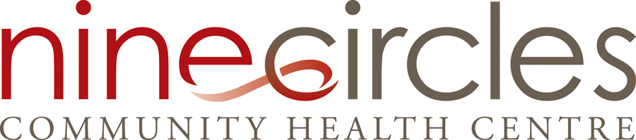

Nine Circles Community Health Centre

Is currently hiring for

HEALTH EDUCATOR

.8 EFT Term

July, 2025 to March 31, 2026

$34.836/hour to $45.462/hour doq

The Health Educator is responsible for the development and facilitation of culturally grounded health promotion education initiatives guided by the evidenced health promotion and prevention needs of the community. The Health Educator is additionally responsible for ensuring the clients and staff have access to the most up to date resources; meaningful engagement of people with lived experience in program planning, delivery and evaluation; as well as Food Bank coordination. The Health Educator supports harm reduction supply distribution and related education opportunities.

Nine Circles encourages application from qualified First Nations, Metis and 2SLGBTQIA community members.

The job is a part-time, 62 hours per two-week period (including holiday pay hours). Regular hours are 7.75 hours per day (net of breaks). The regular work days for this position will fall between 8:00 a.m. and 8:00 p.m. Mondays through Fridays. Regular work hours include a start time of 9:00 a.m. Occasional evenings and weekends shifts may be required. Overtime is not a normal requirement of this position.

The position is classified as Health Educator, on the MAHCP salary scale (WCHREO 2015 Hours). A comprehensive benefit package is provided as per employee eligibility via HEB Manitoba.

A detailed job description stating all position duties, responsibilities and skill requirements is available upon request.

Duties/Responsibilities

Health Promotion:
- Provide leadership in identifying emerging trends and gaps in community knowledge and coordinating a response through program design
- Design and deliver culturally responsive education and training curricula on a variety of sexual health, harm reduction and health promotion initiatives that increases both individual and organizational capacity
- Establish and maintain relevant community networks
- Consult and collaborate with Nine Circles and program teams in the development, delivery and evaluation of programs and resources
- Collaborate with program teams to design and implement health education into community events (e.g. World AIDS Day, community fairs)
- Coordinate access to and/or develop a variety of knowledge translation tools to meet community needs for STBBI awareness, prevention, and education

Knowledge Translation and Exchange:
- Researching trends and gaps in community knowledge and use findings to acquire, adapt, develop, review and evaluate appropriate educational resources
- Regularly review and evaluate resources to reflect best practice and promising practice
- Distribution/promotion of health promotion tools and resources into the community

People with Lived and Living Experience Participation:
- Ensure the meaningful participation of people with lived experience in the development, delivery and evaluation of programs and resources

Client Engagement:
- Distribute harm reduction supplies and provide harm reduction education, resources, and support to clients in collaboration with Nine Circles program teams;
- Coordinate the operations of the Nine Circles Food Bank

Qualifications

Required Education
- Successful completion of an undergraduate degree in a health or social service field preferred.
OR
An equivalent combination of post-secondary education and minimum 3 years relevant experience.

Preferred Education
  - Certification or diploma in Adult Education
  - Certification in Group Facilitation (in person and virtual)

Knowledge, Skills, and Experience
- Minimum of 3 years’ experience in the delivery and design of health education
- Demonstrated ability to develop written resources
- Demonstrated ability to research, analyze and effectively communicate complex information
- Knowledge and understanding of Indigenous cultures and traditions and the impact of colonization on the health and well-being of Indigenous individuals and families
- Knowledge and understanding of sex positivity, sexual health and health equity
- Demonstrated knowledge of and practice in harm reduction approaches
- Demonstrated ability to meaningfully engage people with lived experience in the design, implementation and evaluation of programs
- Demonstrated ability to develop and facilitate education sessions utilizing adult education theories and techniques
- Demonstrated ability to research, develop and evaluate new programs based in evidence and best practice
- Exemplary written and oral communication skills
- Ability to use a strength-based and client-centred approach when working with community and clients

Assets
- Lived experience related to the mandate of Nine Circles

How to Apply

Interested candidates may forward their letter of application and résumé to:

Email: humanresources@ninecircles.ca

Closing date: Wednesday, June 11, 2025 by 4:00 pm.

Nine Circles celebrates diversity and is committed to creating an inclusive environment for all employees. We encourage applications from qualified people who are Indigenous, living with HIV, identify as 2SLGBTQ*, or belong to other traditionally marginalized communities.

Nine Circles thanks all applicants for their interest, however only those selected for further consideration will be contacted.

